Gemma 3 4B-it on RadImageNet-VQA
Zero-shot results on 500 closed-ended and multiple-choice questions
12 October 2026 · source files: vqa_results_gemma3_4b.csv, vqa_scores_gemma3_4b.csv

Summary
Gemma 3 4B-it answered 315 of 500 questions correctly (63.0%, 95% CI 58.7–67.1%). All 500 outputs were a single parseable answer. Like the two Qwen-based models it is strong on anatomy and weak on abnormality, but its errors have a different shape: it leans strongly toward “yes”.
- Anatomy: 84% on multiple-choice (chance 25%) and 81% on yes/no (chance 50%). Both are a few points below the Qwen-based models.
- Abnormality: 52% (interval 42–62%), which is chance level. The model answers “yes” to 98 of 100 questions: it finds all 50 abnormal scans but only 2 of 50 normal ones. This is a constant “yes” answer, not abnormality detection.
- Pathology yes/no: 61% (interval 51–70%). It answers “yes” 75% of the time: recall of “yes” 86%, of “no” 36%.
- Pathology multiple-choice: 37% (interval 28–47%, chance 25%). This is the best result of the three models on this group, and the only weak group where the result clears a Bonferroni threshold (p = 0.005 vs 0.01).
- Regions: weakest are hip (53%, n = 38) and lung (53%, n = 116); strongest is ankle foot (81%, n = 52), but its abnormality questions are inflated by the “always yes” habit (Section 5).
- Versus the other two models (same 500 questions): 315 vs 321 (Qwen2-VL-2B) and 325 (MedVLM-R1). No difference is significant (McNemar p = 0.64 and 0.40). Gemma agrees with each of them on only 73% of questions, whereas the two Qwen-based models agree on 93%.
Each yes/no group was sampled 50% yes and 50% no, so its accuracy equals balanced accuracy. It is not directly comparable to accuracy on the dataset’s natural yes/no mix (Table 4b).

1. Experimental setup
Table 1. Settings
Item | Setting
Model | google/gemma-3-4b-it, zero-shot (no fine-tuning, no in-context examples). General-purpose instruction-tuned model; not trained specifically for medicine.
Dataset | raidium/RadImageNet-VQA, benchmark/test split (9,000 questions on 1,000 CT/MRI images)
Questions used | Closed-ended (yes/no) and multiple-choice (4 options). Open-ended questions excluded.
Sample | 500 questions: 5 groups × 100, random seed 42; every yes/no group is 50 “yes” + 50 “no”. Identical to the sample used for the other models.
Prompt | Same fixed instruction as the other models: only the option letter, or only “Yes” / “No”; input is the image, the question and (for MCQ) the options
Decoding | Greedy (do_sample=False), at most 16 new tokens, batch size 1
Precision | bf16 weights (AutoModelForImageTextToText, device_map="auto")
Answer parsing | MCQ: first standalone letter A–D. Yes/No: first “yes” or “no” in the lowercased output. Text inside <answer>…</answer> is read first if present (it never occurred).
Scoring | Exact match with the reference answer. An unparsed answer would count as wrong (none occurred). 95% Wilson intervals; one-sided exact binomial test against chance.
Hardware | Not recorded in the output files

Table 2. Sample design (100 questions per group)
Group | Format | Example question | Class split | Chance
Anatomy yes/no | Yes/No | Is the knee visible in the image? | 50 / 50 | 50%
Abnormality yes/no | Yes/No | Does the lung look abnormal? | 50 / 50 | 50%
Pathology yes/no | Yes/No | Is there evidence of renal lesion in this image? | 50 / 50 | 50%
Anatomy MCQ | 4 options | Select the correct anatomical region. | random letters | 25%
Pathology MCQ | 4 options | What is the most likely pathology in this image? | random letters | 25%

Prompts (the question and options are filled in per item):
MCQ: You are a medical assistant. Look at this image and answer the following multiple-choice question with ONLY the letter of the correct option (e.g. 'B'), nothing else. Question: … Options: A. … B. … C. … D. …
Yes/No: You are a medical assistant. Look at this image and answer the following question with ONLY the single word 'Yes' or 'No'. Question: …

2. Results by question group
Anatomy questions are answered well. Pathology multiple-choice is above chance, pathology yes/no is borderline, and abnormality is at chance. Pathology MCQ (p = 0.005) is below the Bonferroni threshold for five groups (0.01); pathology yes/no (p = 0.018) is not. The pathology MCQ gain is real but small: 12 points above chance.
Table 3. Accuracy by group
Group | Correct / n | Accuracy | 95% CI | Chance | p vs chance
Anatomy (MCQ) | 84 / 100 | 84% | 75.6–89.9% | 25% | < 0.001
Anatomy (yes/no) | 81 / 100 | 81% | 72.2–87.5% | 50% | < 0.001
Pathology (yes/no) | 61 / 100 | 61% | 51.2–70.0% | 50% | 0.018
Abnormality (yes/no) | 52 / 100 | 52% | 42.3–61.5% | 50% | 0.382
Pathology (MCQ) | 37 / 100 | 37% | 28.2–46.8% | 25% | 0.005
Overall | 315 / 500 | 63.0% | 58.7–67.1% | – | –
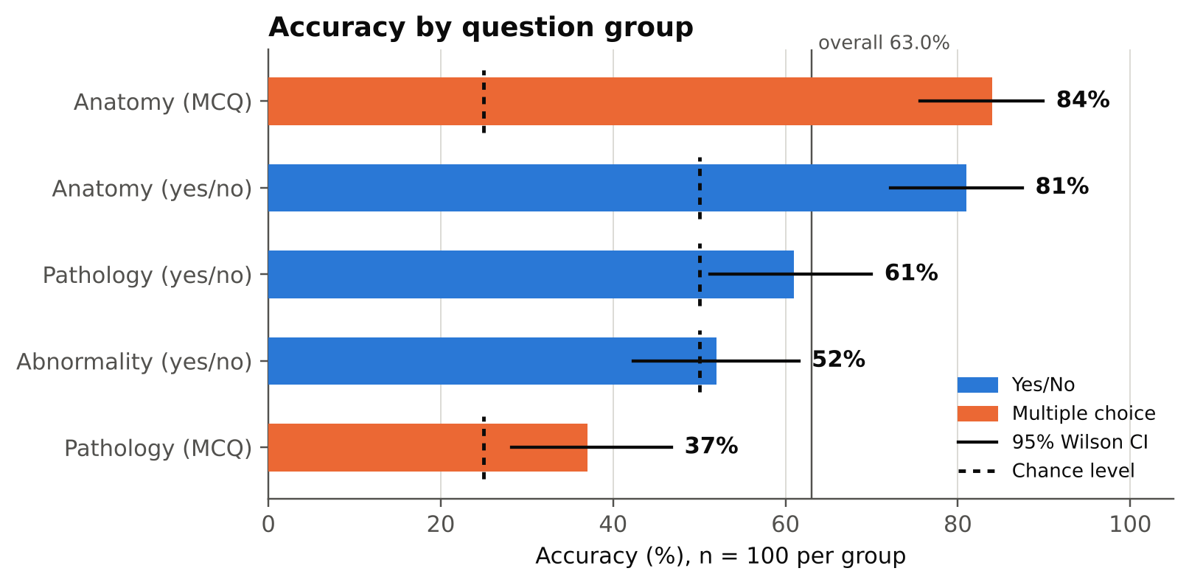
Figure 1. Accuracy by question group with 95% Wilson intervals. Dashed marks show chance level for each group.

3. Yes/No analysis
Gemma’s yes/no errors are dominated by one bias: it says “yes” far too often. The bias grows from anatomy to pathology to abnormality (Figures 2–3, Table 4a).
- Abnormality: the model answers “yes” for 98 of 100 questions. It recognises all 50 abnormal scans but only 2 of 50 normal scans (4%). Its 52% accuracy is exactly what a constant “yes” answer would score on a 50/50 sample, so there is no evidence of abnormality detection.
- Pathology: “yes” for 75 of 100 questions. Recall of “yes” is 86%, of “no” 36%. Errors are 32 false alarms against 7 misses.
- Anatomy: no strong bias (49% “yes”). Errors are balanced: 10 missed structures and 9 structures reported that are not in the scan.
- Across all yes/no questions: 74% of answers are “yes” although exactly 50% are correct as “yes”.
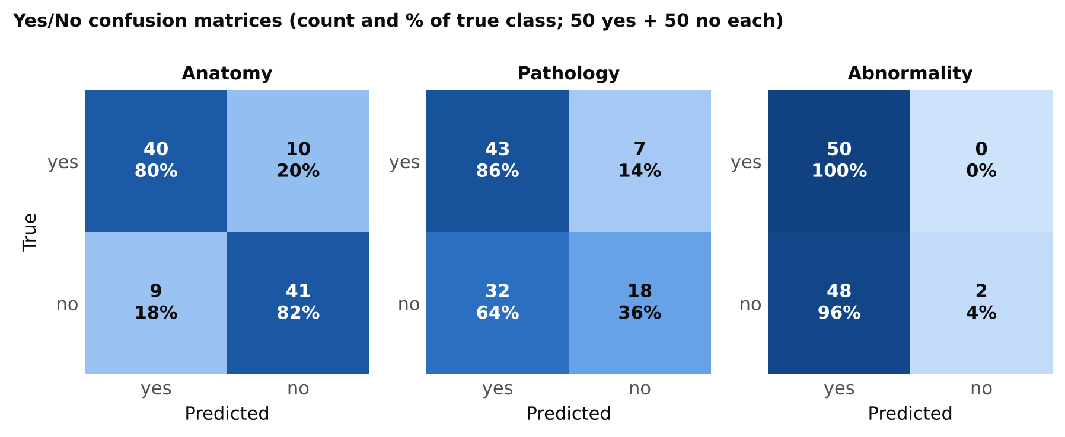
Figure 2. Yes/No confusion matrices. Each cell shows the count and the percentage of the true class.
Table 4a. Yes/No metrics (positive class = “yes”)
Group | Recall yes | Recall no | Precision yes | F1 yes | Predicted yes | Accuracy
Anatomy | 80% | 82% | 81.6% | 0.81 | 49% | 81%
Pathology | 86% | 36% | 57.3% | 0.69 | 75% | 61%
Abnormality | 100% | 4% | 51.0% | 0.68 | 98% | 52%
All yes/no | 88.7% | 40.7% | 59.9% | 0.72 | 74.0% | 64.7%
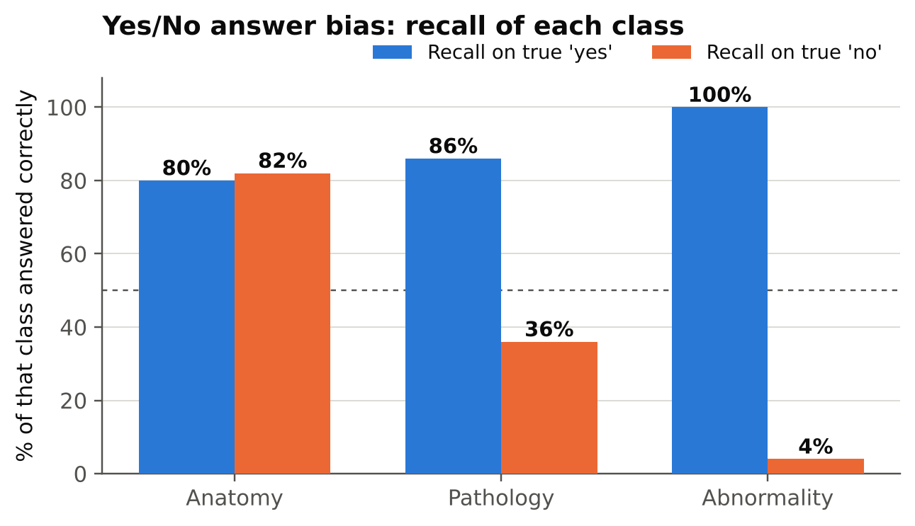
Figure 3. Recall of true “yes” and true “no” questions in each yes/no group. The dashed line marks 50%.
Effect of the sampling design. The full benchmark has more “yes” than “no” answers for abnormality (71.9% yes) and more “no” for pathology (64.1% no). Re-weighting the measured per-class recall to those natural shares gives the estimates in Table 4b. They are rough: each class rests on only 50 questions.
Table 4b. Estimated accuracy at the dataset’s natural yes/no mix
Group | Yes share (full set) | Accuracy on 50/50 sample | Estimated at natural mix | Always-majority baseline
Anatomy | 50.0% | 81.0% | 81.0% | 50.0%
Pathology | 36.0% | 61.0% | 54.0% | 64.1% (always “no”)
Abnormality | 71.9% | 52.0% | 73.0% | 71.9% (always “yes”)
The abnormality figure looks good (73%) only because the natural mix is mostly abnormal and the model says “yes” almost always; it equals the constant-“yes” baseline and carries no skill. On the pathology yes/no mix the model would likely score about 10 points below always answering “no”. These are estimates from re-weighting, not measured results; the natural shares come from the earlier audit of the full split (abnormality 719 yes / 281 no; pathology 719 yes / 1,281 no).

4. Multiple-choice analysis
Anatomy MCQ errors are scattered (16 errors; lung 7, hip 5, abdomen 3, knee 1). Pathology MCQ is the strongest weak-group result of the three models, with a lean toward option B.
- Anatomy: letter recall is 83% (A), 95% (B), 85% (C) and 73% (D). The model’s answer counts are close to the correct-answer counts. Hip is the exception: 3 of 8 correct.
- Pathology: letter recall is only 32–41% for every letter. The model chose B 35 times against 22 correct Bs, and A only 16 times against 25 correct As (9 of the 25 true-A questions went to B). The B excess is borderline (35 vs 25 expected under no bias: p = 0.028, uncorrected).
Table 5. Option-letter statistics
Group | Letter | Correct answers (n) | Model answers (n) | Recall
Anatomy (MCQ) | A | 29 | 27 | 82.8%
 | B | 22 | 27 | 95.5%
 | C | 27 | 25 | 85.2%
 | D | 22 | 21 | 72.7%
Pathology (MCQ) | A | 25 | 16 | 32.0%
 | B | 22 | 35 | 40.9%
 | C | 25 | 28 | 36.0%
 | D | 28 | 21 | 39.3%
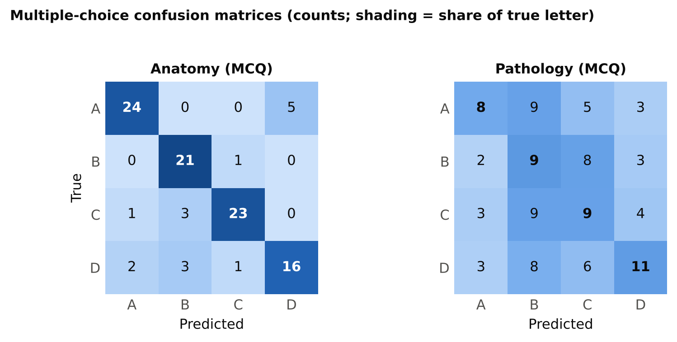
Figure 4. Multiple-choice confusion matrices (counts). In the pathology matrix, column B receives the most answers.
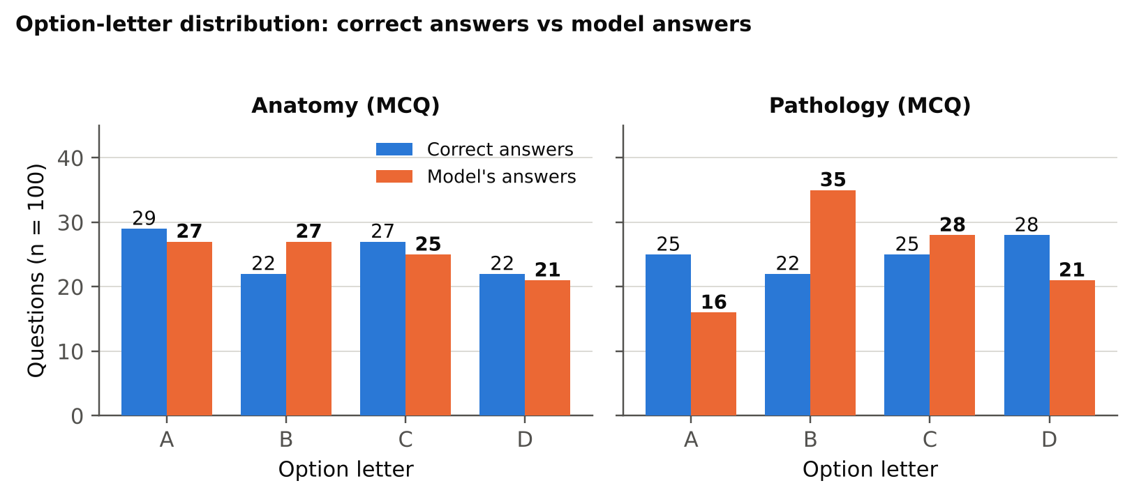
Figure 5. How often each letter is correct versus how often the model chooses it.

5. Anatomical regions
Accuracy varies by region, but most cells are small. Hip (20/38, 53%) and lung (62/116, 53%) are weakest; abdomen, the largest region (163 questions), reaches 60%. Ankle foot (42/52, 81%) is highest.
Read the abnormality column with care. Because the model says “yes” almost always, its abnormality accuracy by region just follows how many scans in that region are abnormal. Ankle foot (11/11) and knee (6/6) look perfect because every scan there is abnormal; abdomen (16/38) and lung (8/26) are poor because most of their scans are normal. The same effect inflates the “All questions” column for ankle foot. Gemma’s anatomy MCQ is weak on hip (3/8) but strong on abdomen (31/34); lung is again lower (18/25, 72%) than abdomen on anatomy questions.
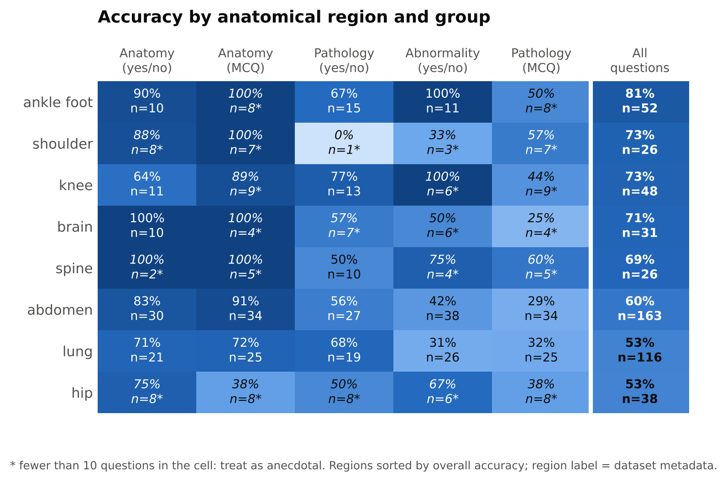
Figure 6. Accuracy by anatomical region (rows) and question group (columns). Starred cells have fewer than 10 questions.

6. Comparison with the other two models
All three models were run on the same 500 questions, so answers can be compared question by question (Table 6, Figure 7).
- Overall: Gemma 315, Qwen2-VL-2B 321, MedVLM-R1 325. The differences (6 and 10 questions) are not significant (McNemar exact p = 0.64 and 0.40).
- Different errors: Gemma gives the same answer as Qwen on 73% of questions and as MedVLM-R1 on 73%, while Qwen and MedVLM-R1 agree with each other on 93%. Gemma’s mistakes are partly different, mainly its “yes” habit.
- Where Gemma is ahead: pathology MCQ (37 vs 34 and 33) and pathology yes/no (61 vs 57 and 57). Where it is behind: anatomy yes/no (81 vs 88 and 86), anatomy MCQ (84 vs 87 and 88) and abnormality (52 vs 55 and 61). None of these per-group differences is significant (McNemar p ≥ 0.12).
- Shared limits: 114 questions (22.8%) are wrong for all three models, 256 (51.2%) are right for all three. A per-question oracle choosing the best of the three would score 77.2%.
Table 6. Gemma 3 4B-it versus each other model (same 500 questions)
Group | Gemma | Other | Both right | Only Gemma | Only other | Both wrong | Same answer
vs Qwen2-VL-2B
Anatomy (yes/no) | 81 | 88 | 77 | 4 | 11 | 8 | 85%
Anatomy (MCQ) | 84 | 87 | 79 | 5 | 8 | 8 | 85%
Pathology (yes/no) | 61 | 57 | 39 | 22 | 18 | 21 | 60%
Abnormality (yes/no) | 52 | 55 | 43 | 9 | 12 | 36 | 79%
Pathology (MCQ) | 37 | 34 | 22 | 15 | 12 | 51 | 58%
Overall (p = 0.64) | 315 | 321 | 260 | 55 | 61 | 124 | 73%
vs MedVLM-R1
Anatomy (yes/no) | 81 | 86 | 76 | 5 | 10 | 9 | 85%
Anatomy (MCQ) | 84 | 88 | 80 | 4 | 8 | 8 | 86%
Pathology (yes/no) | 61 | 57 | 41 | 20 | 16 | 23 | 64%
Abnormality (yes/no) | 52 | 61 | 42 | 10 | 19 | 29 | 71%
Pathology (MCQ) | 37 | 33 | 23 | 14 | 10 | 53 | 60%
Overall (p = 0.40) | 315 | 325 | 262 | 53 | 63 | 122 | 73%
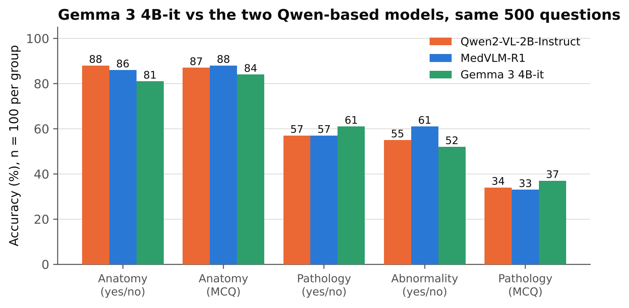
Figure 7. Accuracy of the three models on each group (same questions).
The three models are within about 10 points of each other on every group. With 100 questions per group, only differences of roughly 15 points or more would be reliable.

7. Error analysis
- Normal scans called abnormal: 48 of 50. The only two correct “no” answers were one lung scan and one abdomen scan (lung 1/19, abdomen 1/23, brain 0/3, hip 0/2, shoulder 0/2, spine 0/1).
- Pathology negatives: among the 39 pathology_closed_neg questions (all true “no”), the model answered “yes” 27 times (12 correct, 31%). Among the 61 pathology_closed_pos questions it scored 80% (49 correct), including 43 of 50 true “yes”. The 11 true-“no” questions in that second type were answered correctly 6 times; the 5 errors were renal lesion (abdomen), osseous lesion (brain), calcific tendinosis (abdomen), cystic lesions (abdomen) and plantar plate tear (ankle foot). With these sample sizes this is an observation, not a conclusion.
- Anatomy errors: 19 in total. 10 are missed “yes” answers (abdomen 4, lung 4, ankle foot 1, knee 1). 9 are structures reported that are not in the scan (knee 3, hip 2, lung 2, shoulder 1, abdomen 1); the Qwen-based models made only 2–3 of this type.
- Formatting: no unparsed outputs. Every raw output was exactly one token: “Yes”, “No”, or a letter.
Table 7. Examples of wrong answers
Group | Region | Question | True | Model
Anatomy yes/no | lung | Can you identify the lung in this image? | yes | no
Anatomy yes/no | knee | Can you see the ankle foot? | no | yes
Abnormality | lung | Does the lung look abnormal? | no | yes
Abnormality | abdomen | Is there an abnormality present? | no | yes
Pathology yes/no | abdomen | Is the abdomen affected by bowel mass? | yes | no
Pathology yes/no | knee | Are there signs of postoperative acl reconstruction? | no | yes
Pathology MCQ | abdomen | Select the pathology that best describes this image: | B | D
Pathology MCQ | abdomen | What pathology is shown in this scan of abdomen | A | B
The results file stores the question text but not the answer options, so the options behind a wrong MCQ letter cannot be read from it.

8. Limitations
- Sample size: 100 questions per group gives intervals of about ±9 points. Differences of a few points between groups or between models are not reliable, and most region-by-group cells have fewer than 30 questions.
- One run, one prompt: greedy decoding with a single fixed prompt. The “yes” bias may depend on the prompt wording (“You are a medical assistant … ONLY the single word”); this was not tested. Precision (bf16 here) was not varied.
- Sampling: yes/no groups are balanced by design. Natural-mix figures in Table 4b are estimates.
- Region labels: regions come from the dataset’s location field; they are not verified against the images.
- Possible overlap: the dataset is derived from RadImageNet; overlap with the model’s training data is unknown.
- Not a clinical evaluation: these results describe benchmark behaviour only.

9. Files and next steps
Files produced with this report: seven figures (PNG and PDF, figures/) and seven tables (CSV, tables/) matching Tables 3, 4a, 4b, 5, the two parts of Table 6 and the region breakdown in Figure 6.
- Run MedGemma 4B-it on the same 500 questions, then compare all four models with paired counts and a correction for the five groups.
- For the abnormality and pathology yes/no groups, report balanced accuracy and recall of both classes next to accuracy; accuracy alone hides the “always yes” behaviour.
- Add the answer options and the GPU used to the saved results for the next runs.

